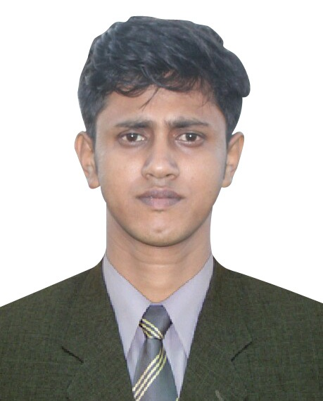
RESUME
RASEL MAHMUD
Address: Maradia hat, Blok- G, Road-3,
Plot-52, Rampura, Dhaka.
Mobile: 01814706152, E-mail: raselgub0803@gmail.com

CAREER OBJECTIVE | Intending to work in challenging and competitive environment where strong sense of responsibility and commitment is required. And thus finding out the means through study, observation and conference which can help to build up an excellent career in the long run.

EDUCATIONAL QUALIFICATION | - Masters of Business Administration (M.B.A)  Institution Name : Green University of Bangladesh  Subject : Finance  Status : Running  Duration : 1 Year  - Bachelor of Business Administration (B.B.A)  Institution Name : Green University of Bangladesh  Subject : Finance  Result : CGPA-3.16(Out of 4.00)  Passing Year : 2012  Duration : 4 Year  - Higher Secondary Certificate (H.S.C)  Institution Name : Adda Degree College  Group : Business Studies  Result : GPA- 3.00 (Out of 5.00)  Passing Year : 2006  Board : Comilla  Duration : 2 Year  - Secondary School Certificate (SSC)  Institution Name : Krishnapur High School.  Group : Business Studies  Result : GPA- 2.50 (Out of 5.00)  Passing Year : 2004  Board : Comilla
LANGUAGE  PROFICIENCY | Capable to communicate and have good writing, reading skill in both Bengali and English

COMPUTER SKILLS | - Computer Fundamentals  - Operating System-Windows-XP, Windows-7  - Microsoft office Program  (Ms Word, MS Excel, MS Access, Ms PowerPoint)  - Internet browsing and Communications
PERSONAL  ATTRIBUTES | - Energetic & Dynamic  - Honest & Punctual  - Quick Learner  - Good as a team member  - Like to take the challenge  - To know more people and more culture.

PERSONAL INFORMATION | Name: Rasel Mahmud  Father's Name: MD. Shamsul Alam  Mother's Name: Shamsun Naher  Date of Birth: 06/09/1988  Religion: Islam  Gender: Male  Marital Status: Married  Height : 5'-9"  Nationality: Bangladeshi by Birth.  National Id: 19881910911261614

PERMANENT ADDRESS | C/O- MD. Shamsul Alam,  Vill- Pombish, PO: Adda Bazer,  PS: Barura, Dist: Comilla-3560.

EXPERIENCE | 1.Assistance Production Manager (factory)  Employment (From: 02 May , 2018 )  Colour King Group  (100% Export oriented Garments & Accessories Manufacturer)  Factory: 244, Uttar Badda, Satarkul Road, Badda, Dhaka-1212.  Head Office: 87, New Eskaton Road , Home Town Apartment (6th &7th floor)  Block-A, Ramna Dhaka-1000, Bangladesh.  2. Sr. Field Officer  (From: 20 June, 2016 To 30 April, 2018 )  Super Star Group Limited (SSG)  Chittagong Show room  181/5/ Goulshan Plaza, Nondankanan,  3 Pole, New Market, Chittagong.  Department: Seals  Head Office: UCEP Cheyne Tower (3rd Floor)  25,Segun Bagicha, Ramna Dhaka-1000,Bangladesh  3. Production Officer & QC  (From: March 01, 2014 To 18 June, 2016).  STS (BD)  (100% Export oriented Garments & Accessories Manufacturer.)  Factory: Company Location : 234 Fakirarpool(1st Floor), Motijheel C/A, Dhaka-1000, Bangladesh.  4. Promotion Camping  * Airtel  * Robi  * Marico  * Life boy Hand wash.  * horlicks

REFERENCE | Name: Mohibul Hassan Khan (Shaon)  Designation: Vice Chairman & MD  Organization: Colour King Group  Mobile: +8801819292639  Factory: 244, Uttar Badda, Satarkul Road, Badda, Dhaka-1212. | Name: Shaifuzzama Bhuiyan(Sajeeb)  Designation: Production Manager  Organization: Colour King Group  Mobile: 01725067568  Factory: 244, Uttar Badda, Satarkul Road, Badda, Dhaka-1212.

I declare that all the information above is true-

....................................
Signature of
Rasel Mahmud.

